The AI Divide

The AI Divide

Activity Overview
Students complete a logic puzzle challenge to analyze how differences in AI access affect people’s ability to learn, work, and participate fully in a technology-driven world.
Learning Objective  Students explain that AI access is not distributed equally across different communities and explore the consequences of unequal access. | Standards & Competencies  - 1b (Identify and evaluate differences)  - 2b (Examine AI use and outputs)  - CCSS.MATH.PRACTICE.MP1: Make sense of problems and persevere
Materials  - AI Access Cards  - Student Worksheet  - Class poster with Fair AI Guidelines | Preparation  - Prepare Student Worksheets and AI Access Cards for each student.  - Display Fair AI Guidelines poster.

Launch (2 minutes)
Slide | Exploration Guide
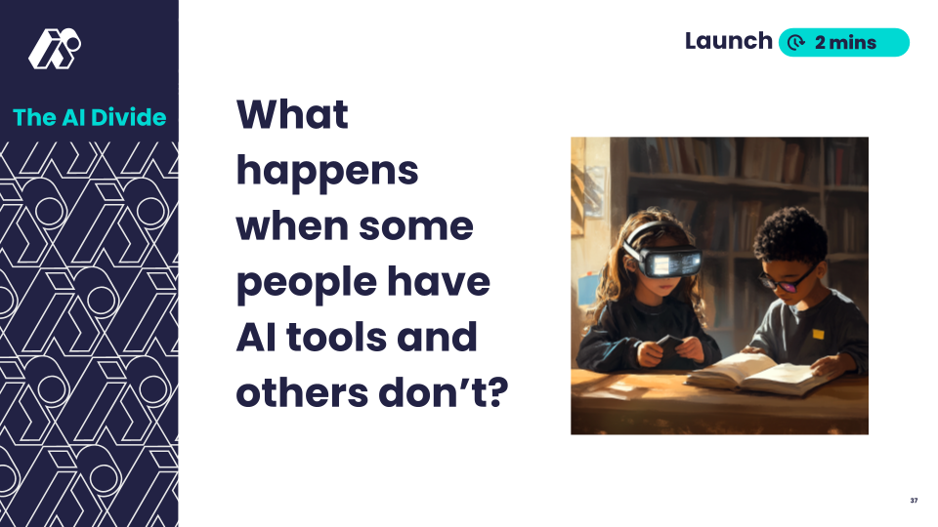 | Say: "Today, AI tools can help people do schoolwork, write, solve problems, and even create art. But not everyone has access to these tools. What do you think happens when some students can use AI, but others can’t? Is that fair?"  Look For:  - “AI tools can help you accomplish some tasks faster.”  - “It’s not fair if only some people can use AI tools.”  - “It would be like if only some people could have calculators or the internet.”  Common Student Misconceptions:  - AI is free and easy for everyone to use  - Response: “AI can be a great tool, but not everyone has the same access.”
💡Teaching Tips: Use a think-pair-share to give students processing time to think about the question before sharing aloud.

Play (6-8 minutes)
Slide | Exploration Guide
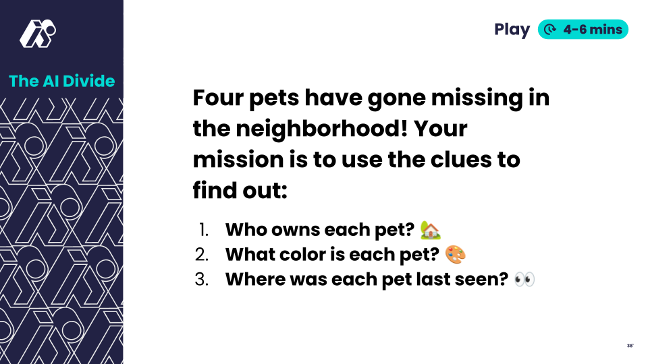 | Say: "Now, you’ll work in small groups to complete a task. But not everyone will have the same level of AI access!"  Distribute student worksheets and 1-2 AI Access cards to each student. In pairs or small groups, use the clues and access cards to solve the puzzle. Have students discuss the reflection questions in their groups.  Look For:  - "This isn't fair!"  - "How are we supposed to finish without help?"  - "Why do they get more AI help than us?"  - "This is very easy with a lot of AI help."
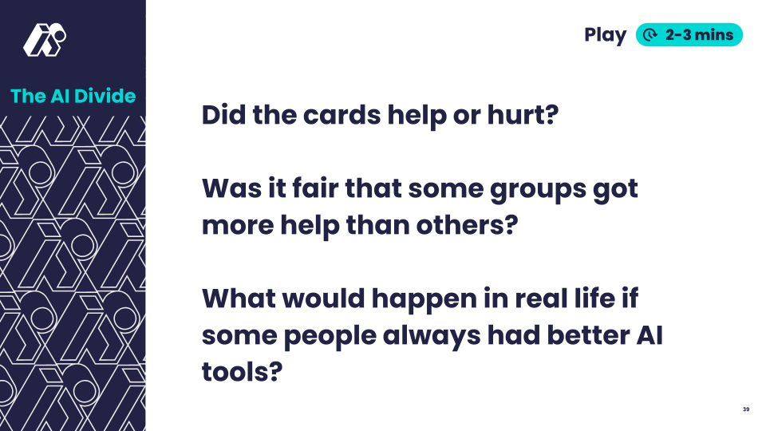 | Say: "Let's talk about what just happened. "  Ask: “Did the cards help or hurt? Was it fair that some groups got more help than others? What would happen in real life if some people always had better AI tools?”  Look For:  - “We solved it fast because our card gave us a correct row!”  - “We had to ignore our AI card because it was wrong.”  - “It felt unfair—some groups got way more help.”  - “This happens in real life if people don’t have computers or internet.”
💡Teaching Tip: Provide sentence starters like:
- "It felt fair/unfair because _______."
- "Our group had trouble because ________."

Land (3-6 minutes)
Slide | Exploration Guide
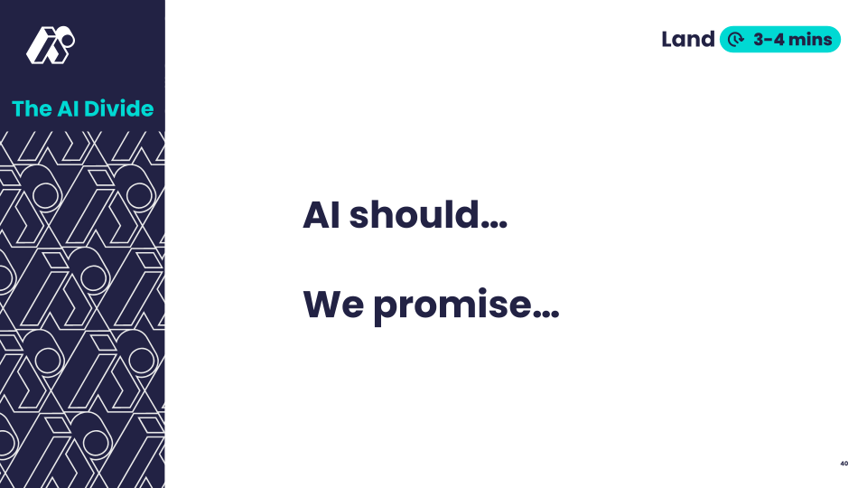 | Say: "Now let’s put everything together. What should be true about AI to make it more fair? What could we do to help make AI more fair for everyone?”  Students propose wording for Fair AI guideline statement. Record statements with students OR show the next slide.  Look For:  - "AI should be available to everyone"  - "Everyone deserves the same chances with AI"  - “We should speak up when we notice differences in AI access.”
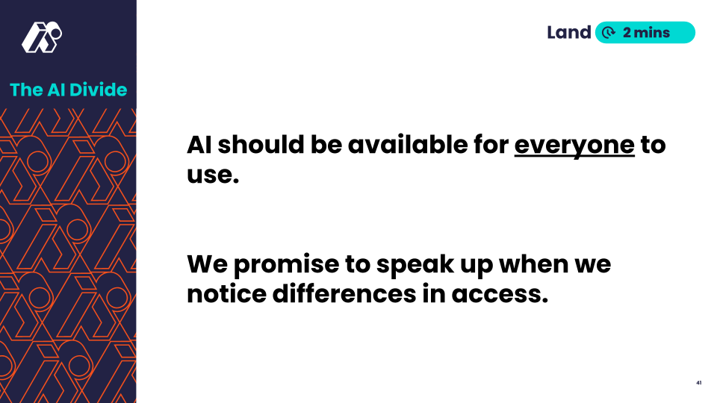 | Share this slide or the written version of the statements agreed upon by the class.  Say: "Here's one way we could phrase our learning. Does this capture our ideas, or do you prefer your wording?
💡Teaching Tip: Encourage students to use their own words - there is no single "right" answer. Only show the suggested guideline wording if students struggle to capture the core concept.

